**[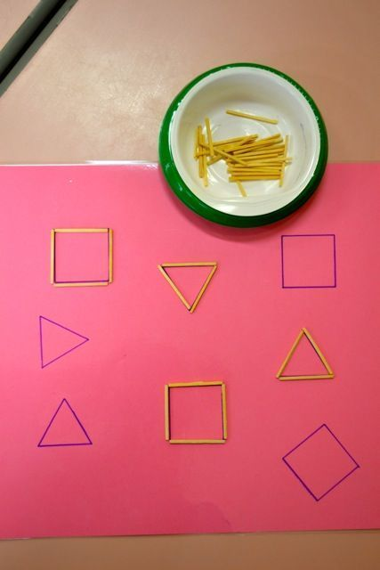](http://idee-maitresse.fr/atelier/des-ateliers-pour-la-geometrie-la-maternelle/)[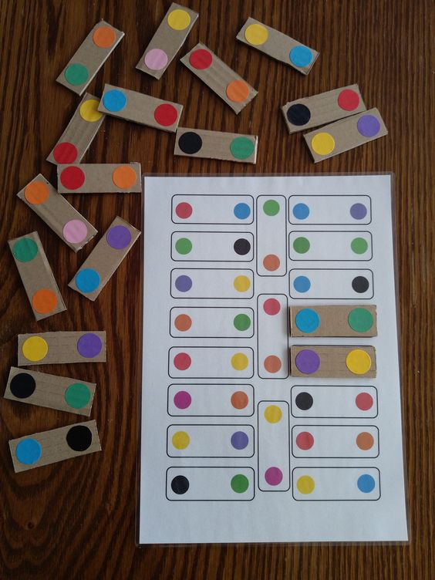](https://ztorbynauczycielki.pl/zabawa-kolorowe-kartoniki/)[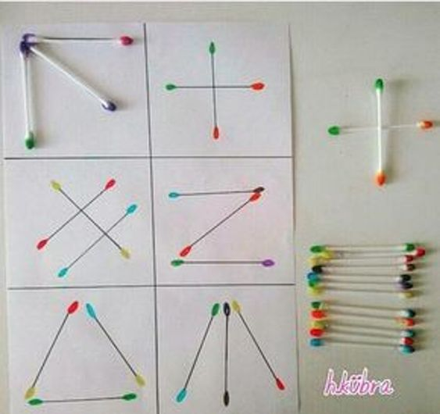](https://www.aufeminin.com/bebe/activites-montessori-bebe-s2142529.html)[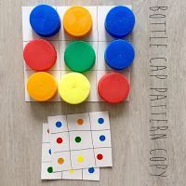](https://penitenciasyretos.blogspot.com/2019/07/10-ideas-para-elaborar-juegos.html)**