**[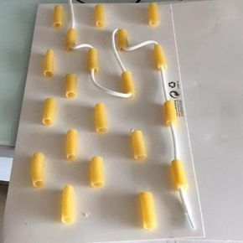](http://www.annekaz.com/evde-yapilabilecek-20-okul-oncesi-aktivite.html)[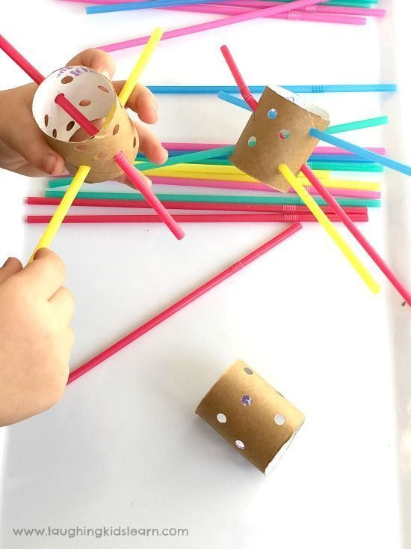](https://laughingkidslearn.com/fine-motor-threading-activity-using-straws-and-cardboard-tubes/?utm_medium=social&utm_source=pinterest&utm_campaign=tailwind_tribes&utm_content=tribes&utm_term=424381584_14383270_104369)**

**[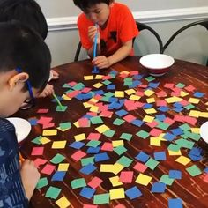](https://cz.pinterest.com/pin/449585975308034934/)**

**[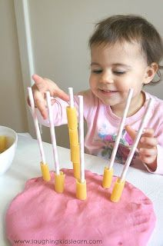](https://www.meumeninominhavida.com.br/2019/07/coordenacao-motora.html)**