**[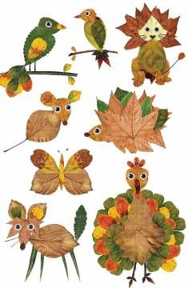](https://www.okuloncesitr.net/sonbahar-etkinligi-93/)[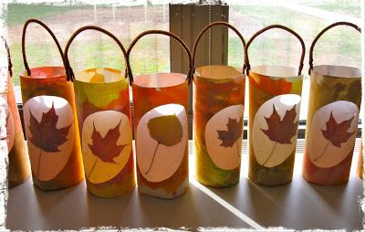](http://fairydustteaching.com/2012/11/leaf-lanterns-tutorial/)[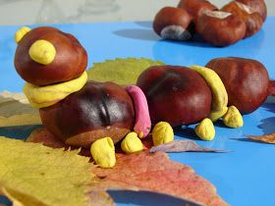](http://zazitkyrodinky.blogspot.com/2015/10/zviratka-z-kastanu_24.html?spref=pi&m=1)**

**[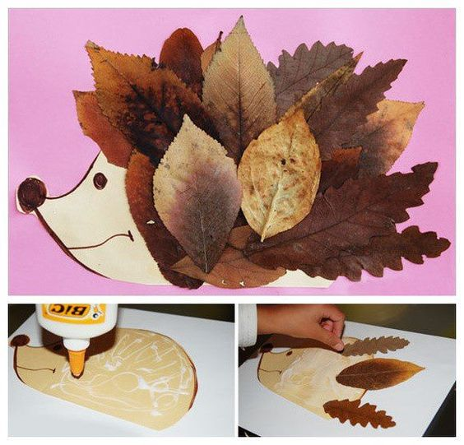](http://www.garotacriatividade.com/)**