**[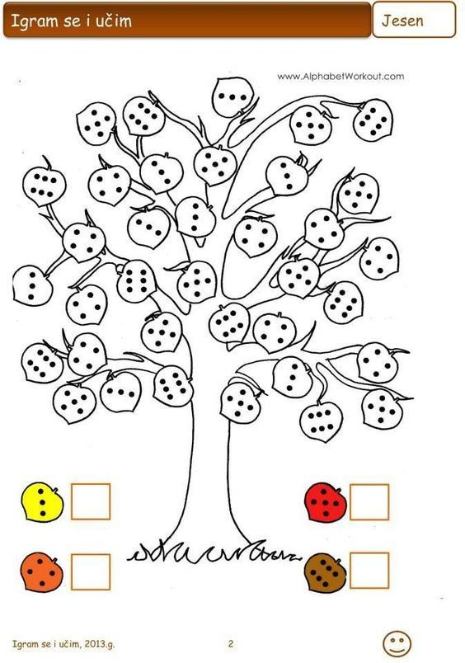](https://vk.com/wall-68130961_82643)**

**[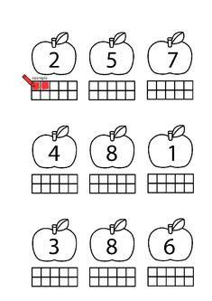](https://mungfali.com/page/C3CB9DA913BE665D5FA38246887EC10FF5DD104D/kindergarten_math_worksheets)[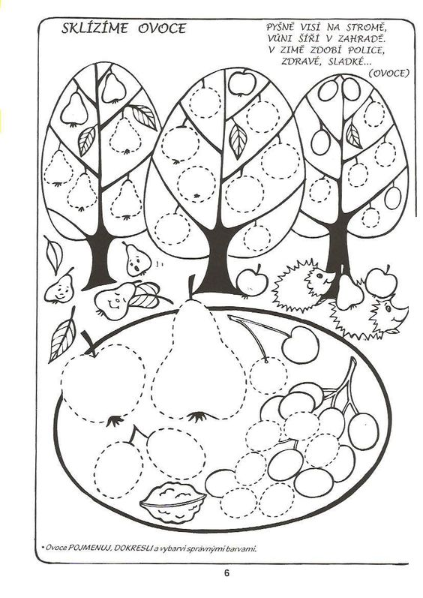](https://vyrabimesdetmi.rajce.idnes.cz/podzim/#sklizime-ovoce.jpg)[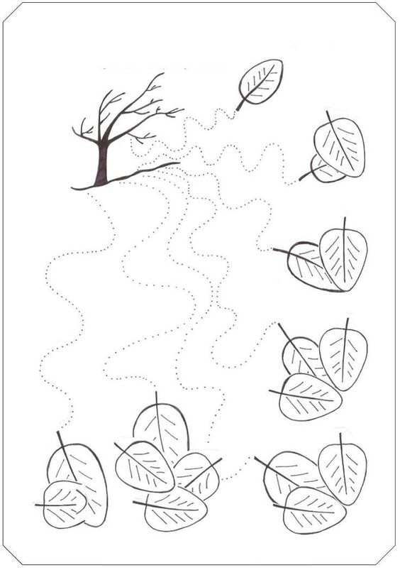](https://www-preschoolactivities-us.cdn.ampproject.org/c/www.preschoolactivities.us/fall-trace-line-worksheet-for-kids/amp/)**